PROJECT TEMPLATE

INTRODUCTION

1. OUR TEAM PROJECT NAME IS DESIGNING PROFESSIONAL BUSINESS CARD. **Sign in to Canva:** If you don't already have a Canva account, you'll need to sign up for one. You can use your Google, Facebook, or email account to create an account.
2. **Start a New Design:** After logging in, click the "Create a design" button on the top right corner of the Canva dashboard. In the search bar, type "Business Card" and select the relevant template size.
3. **Choose a Business Card Template:** Canva offers a variety of free and paid business card templates. Browse through the available templates and choose one that matches your style and brand. You can click on a template to get a closer look.
4. **Customize the Design:** Once you've chosen a template, you can customize it to suit your needs. Here are some customization options:
   1. **Text:** Click on any text element in the design to edit the text. Change the text, font, size, color, and alignment to match your branding.
   2. **Images:** If the template includes images or placeholders, you can replace them with your own images. Click on the image element to upload your own pictures or select from Canva's library of images.
   3. **Colors:** Adjust the background color, text color, and other design elements to match your branding colors.
   4. **Layout:** Move and resize elements to create the layout you want.
   5. **Add Elements:** Canva provides a wide range of elements like shapes, lines, icons, and illustrations that you can add to your design.
5. **Include Your Information:** Make sure to include the essential information on your business card. This typically includes your name, job title, company name, phone number, email address, website, and any social media handles. Add or edit text elements as needed.
6. **Save Your Design:** It's essential to save your work frequently. Click the "File" menu and choose "Save" to save your business card design in Canva. You can also download it as a PDF or image file at any time.
7. **Order Printed Cards (Optional):** If you're satisfied with your design and want physical business cards, Canva allows you to order professional prints. Click the "Order prints" button, and Canva will guide you through the printing and delivery process. This is a paid service.
8. **Finalize and Share:** After you've completed your business card design, review it carefully for any errors. Once you're satisfied, you can share it electronically by downloading the file or printing it locally.

EMPATHY MAP.

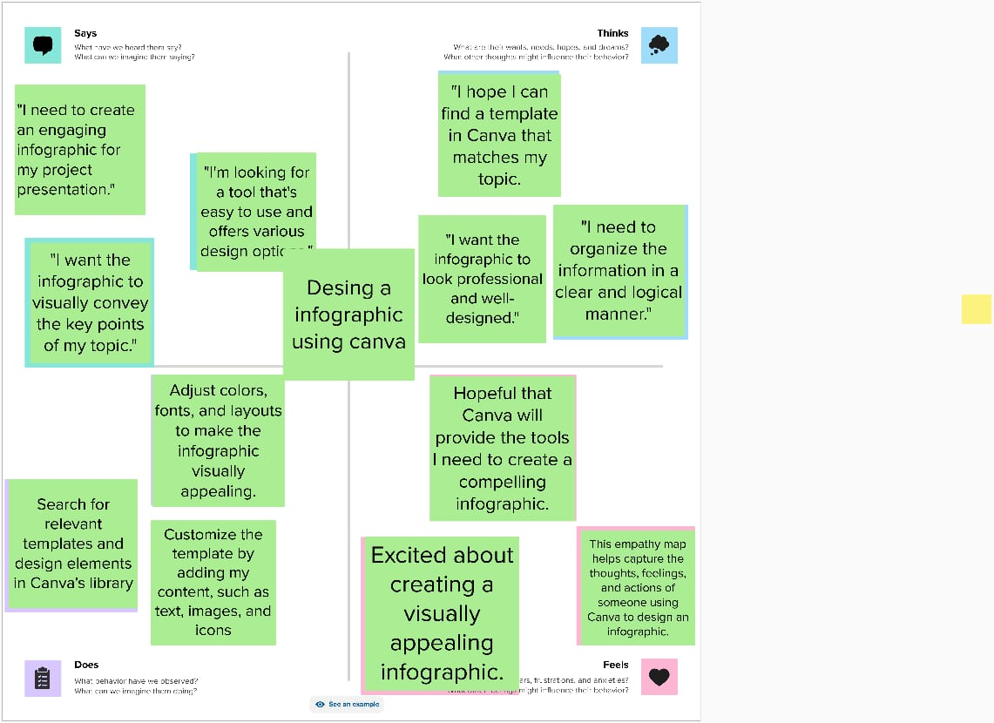Top of Form

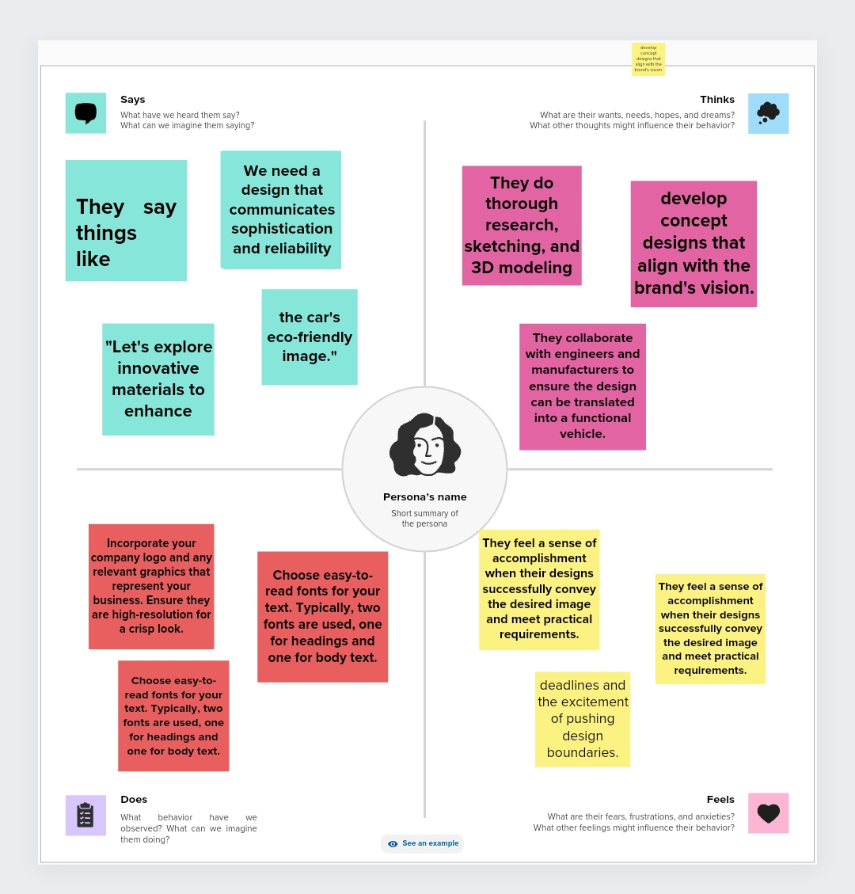

BRAINSTOERMING

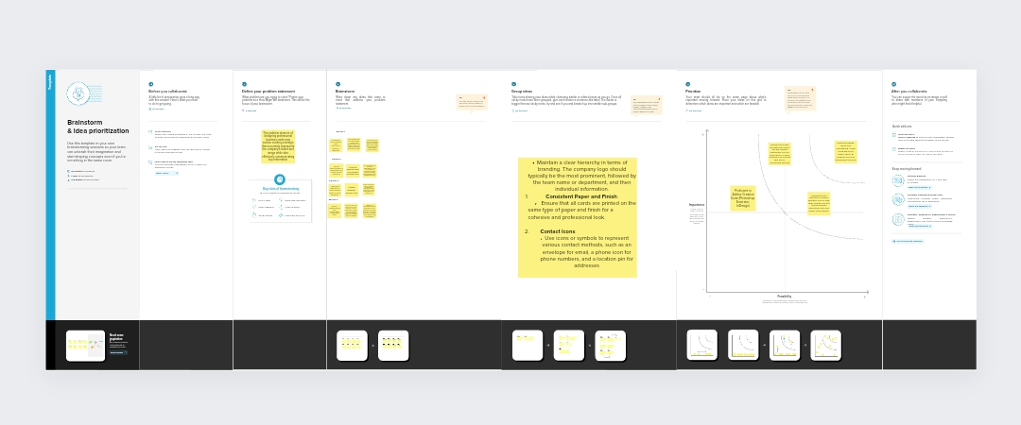



PROJECT RESULT

EXPLANATION AUDIO

